**Linear regression homework**

**Sams Khan**

* First I read the homework prompt, I knew I had to used the equation
  + ***Y = a + bX***, where is the explanatory variable and ***Y*** is the dependent variable. The slope of the line is ***b***, and ***a*** is the intercept
* Created my mean function
  + simply returns mean given data
* Created variance function that
  + uses the mean function and implements variance equation to return the variance
* Covariance function so we can implement to find the optimal coefficient when we calculate it
* Coefficient functions returns b0(slope) and b1 as intercept

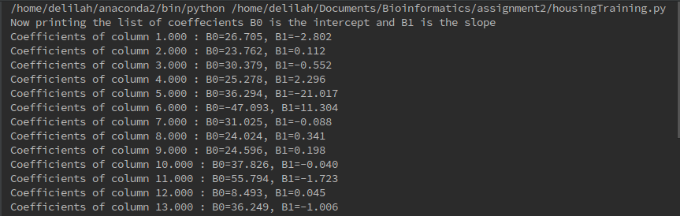

* Computing the linear regression
  + creating a list for storing the prediction values ypred
  + store y values from training data in yArr
  + read training data and store in array
  + grab the b0 and b1 per column
  + iterate thrugh test data to input the x values to compute the y prediction values
  + cast the y prediction values in an array
* plotting the ground vs truth

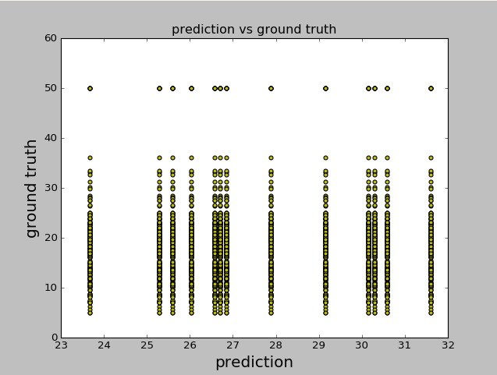

* Implemented residual sum function
  + Running into issue trying to parse the array
  + Unable to get results from residual sum
* 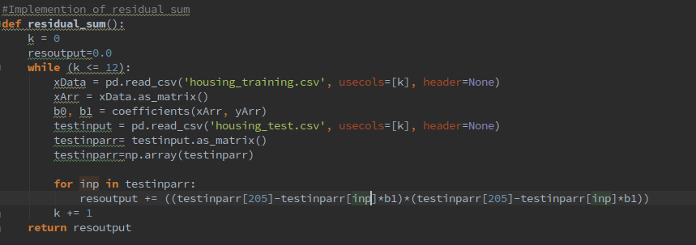Implementation of method.